Program1

#GRAPHICALLY
import matplotlib.pyplot as plt
import csv

x=[]
y=[]

with open('excel.csv', 'r') as csvfile:
plots= csv.reader(csvfile, delimiter=',')
for row in plots:
x.append(int(row[0]))
y.append(int(row[1]))

plt.plot(x,y, marker='o')

plt.title('Data from the CSV File: People and Expenses')

plt.xlabel('Number of People')
plt.ylabel('Expenses')

plt.show()

output

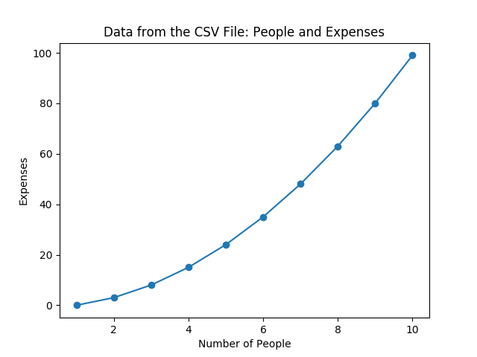

program2

#GRAPHICALLY
import matplotlib.pyplot as plt
import csv

x=[]
y=[]
z=[]
with open('excel.csv', 'r') as csvfile:
plots= csv.reader(csvfile, delimiter=',')
for row in plots:
x.append(int(row[0]))
y.append(int(row[1]))
z.append(int(row[2]))

plt.plot(x,y, marker='o')
plt.plot(x,z, marker='o')

plt.title('Data from the CSV File: People and Expenses')

plt.xlabel('Number of People')
plt.ylabel('Expenses')
plt.savefig('harshitha.png')
plt.show()

output

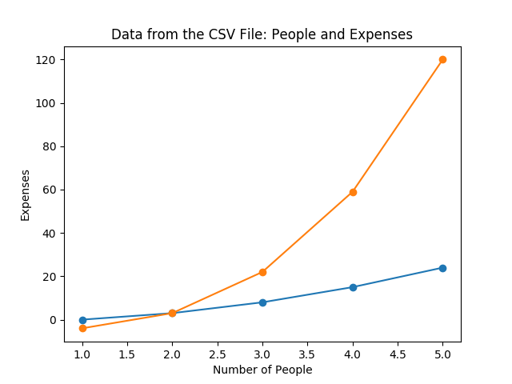

program3

#
import matplotlib.pyplot as plt

# line 1 points
x1 = [1,2,3]
y1 = [2,4,1]
# plotting the line 1 points
plt.plot(x1, y1, label = "line 1")

# line 2 points
x2 = [1,2,3]
y2 = [4,1,3]
# plotting the line 2 points
plt.plot(x2, y2, label = "line 2")

# naming the x axis
plt.xlabel('x - axis')
# naming the y axis
plt.ylabel('y - axis')
# giving a title to my graph
plt.title('Two lines on same graph!')

# show a legend on the plot
plt.legend()

# function to show the plot
plt.show()

output

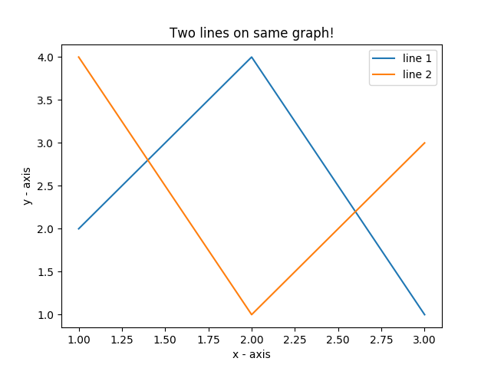

program4

#
import matplotlib.pyplot as plt

# x axis values
x = [1,2,3,4,5,6]
# corresponding y axis values
y = [2,4,1,5,2,6]

# plotting the points
plt.plot(x, y, color='green', linestyle='dashed', linewidth = 3,
marker='o', markerfacecolor='blue', markersize=12)

# setting x and y axis range
plt.ylim(1,8)
plt.xlim(1,8)

# naming the x axis
plt.xlabel('x - axis')
# naming the y axis
plt.ylabel('y - axis')

# giving a title to my graph
plt.title('Some cool customizations!')

# function to show the plot
plt.show()

output

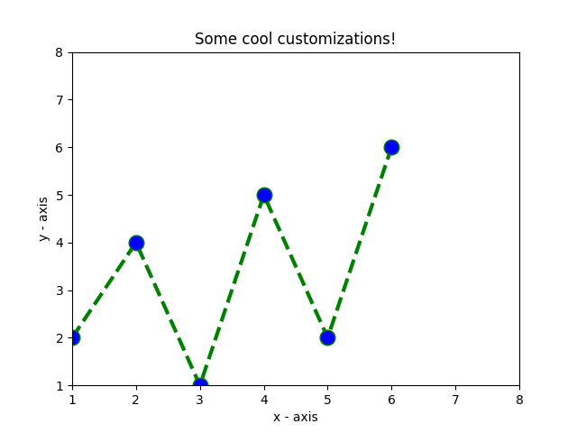

program5

#
import matplotlib.pyplot as plt

# frequencies
ages = [2,5,70,40,30,45,50,45,43,40,44,
60,7,13,57,18,90,77,32,21,20,40]

# setting the ranges and no. of intervals
range = (0, 100)
bins = 10

# plotting a histogram
plt.hist(ages, bins, range, color = 'green',
histtype = 'bar', rwidth = 0.8)

# x-axis label
plt.xlabel('age')
# frequency label
plt.ylabel('No. of people')
# plot title
plt.title('My histogram')

# function to show the plot
plt.show()

output

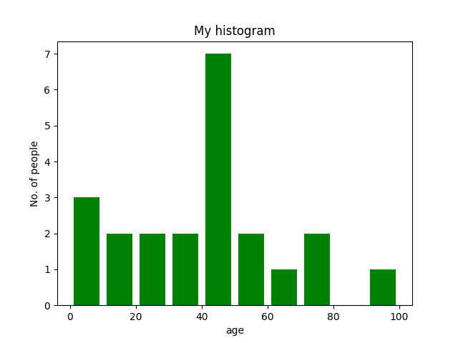

program6

import matplotlib.pyplot as plt

# x-axis values
x = [1,2,3,4,5,6,7,8,9,10]
# y-axis values
y = [2,4,5,7,6,8,9,11,12,12]

# plotting points as a scatter plot
plt.scatter(x, y, label= "stars", color= "green",
marker= "*", s=30)

# x-axis label
plt.xlabel('x - axis')
# frequency label
plt.ylabel('y - axis')
# plot title
plt.title('My scatter plot!')
# showing legend
plt.legend()

# function to show the plot
plt.show()

output

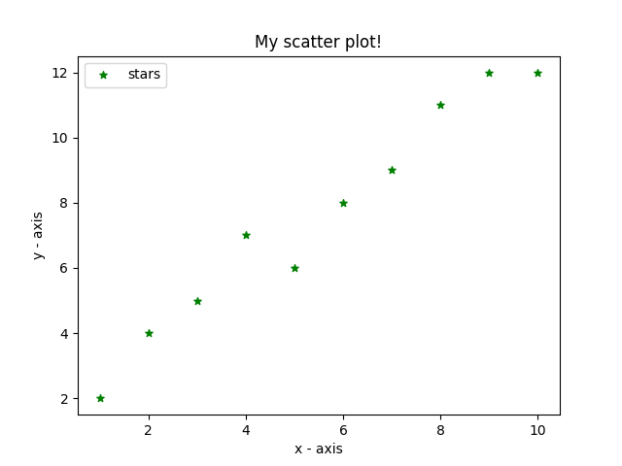

program7

# importing required modules
import matplotlib.pyplot as plt
import numpy as np

# function to generate coordinates
def create_plot(ptype):
# setting the x-axis vaues
x = np.arange(-10, 10, 0.01)

# setting the y-axis values
if ptype == 'linear':
y = x
elif ptype == 'quadratic':
y = x**2
elif ptype == 'cubic':
y = x**3
elif ptype == 'quartic':
y = x**4

return(x, y)

# setting a style to use
plt.style.use('fivethirtyeight')

# create a figure
fig = plt.figure()

# define subplots and their positions in figure
plt1 = fig.add_subplot(221)
plt2 = fig.add_subplot(222)
plt3 = fig.add_subplot(223)
plt4 = fig.add_subplot(224)

# plotting points on each subplot
x, y = create_plot('linear')
plt1.plot(x, y, color ='r')
plt1.set_title('$y_1 = x$')

x, y = create_plot('quadratic')
plt2.plot(x, y, color ='b')
plt2.set_title('$y_2 = x^2$')

x, y = create_plot('cubic')
plt3.plot(x, y, color ='g')
plt3.set_title('$y_3 = x^3$')

x, y = create_plot('quartic')
plt4.plot(x, y, color ='k')
plt4.set_title('$y_4 = x^4$')

# adjusting space between subplots
fig.subplots_adjust(hspace=.5,wspace=0.5)

# function to show the plot
plt.show()

output

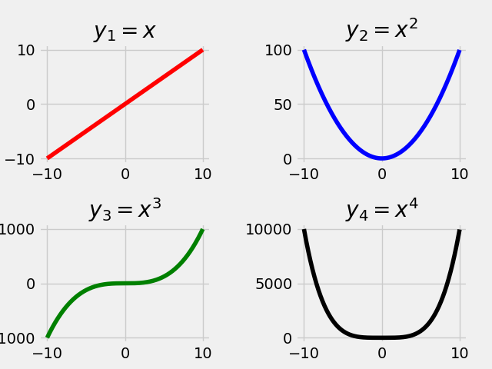

program8

#
from mpl_toolkits.mplot3d import axes3d
import matplotlib.pyplot as plt
from matplotlib import style
import numpy as np

# setting a custom style to use
style.use('ggplot')

# create a new figure for plotting
fig = plt.figure()

# create a new subplot on our figure
# and set projection as 3d
ax1 = fig.add_subplot(111, projection='3d')

# defining x, y, z co-ordinates
x = np.random.randint(0, 10, size = 20)
y = np.random.randint(0, 10, size = 20)
z = np.random.randint(0, 10, size = 20)

# plotting the points on subplot

# setting labels for the axes
ax1.set_xlabel('x-axis')
ax1.set_ylabel('y-axis')
ax1.set_zlabel('z-axis')

# function to show the plot
plt.show()

output

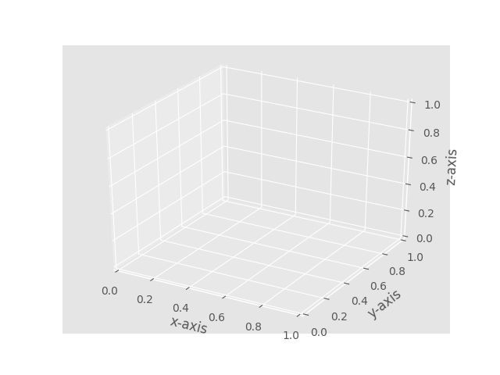

program9

# importing required modules
from mpl_toolkits.mplot3d import axes3d
import matplotlib.pyplot as plt
from matplotlib import style
import numpy as np

# setting a custom style to use
style.use('ggplot')

# create a new figure for plotting
fig = plt.figure()

# create a new subplot on our figure
ax1 = fig.add_subplot(111, projection='3d')

# defining x, y, z co-ordinates for bar position
x = [1,2,3,4,5,6,7,8,9,10]
y = [4,3,1,6,5,3,7,5,3,7]
z = np.zeros(10)

# size of bars
dx = np.ones(10) # length along x-axis
dy = np.ones(10) # length along y-axs
dz = [1,3,4,2,6,7,5,5,10,9] # height of bar

# setting color scheme
color = []
for h in dz:
if h > 5:
color.append('r')
else:
color.append('b')

# plotting the bars
ax1.bar3d(x, y, z, dx, dy, dz, color = color)

# setting axes labels
ax1.set_xlabel('x-axis')
ax1.set_ylabel('y-axis')
ax1.set_zlabel('z-axis')

plt.show()

output

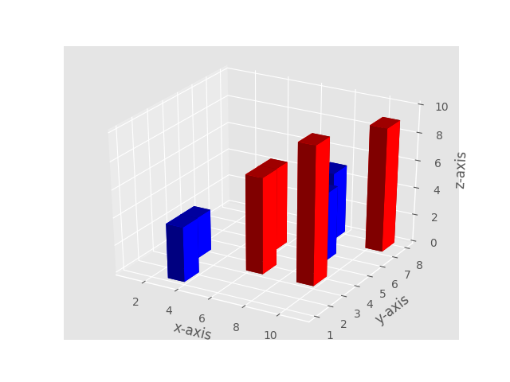

program10

# importing required modules
from mpl_toolkits.mplot3d import axes3d
import matplotlib.pyplot as plt
from matplotlib import style
import numpy as np

# setting a custom style to use
style.use('ggplot')

# create a new figure for plotting
fig = plt.figure()

# create a new subplot on our figure
ax1 = fig.add_subplot(111, projection='3d')

# get points for a mesh grid
u, v = np.mgrid[0:2*np.pi:200j, 0:np.pi:100j]

# setting x, y, z co-ordinates
x=np.cos(u)*np.sin(v)
y=np.sin(u)*np.sin(v)
z=np.cos(v)

# plotting the curve
ax1.plot_wireframe(x, y, z, rstride = 5, cstride = 5, linewidth = 1)

plt.show()

output

